Overview  Country or Region: France  Industry: Retail  Customer Profile  FNAC is France’s largest retailer of cultural and consumer electronic goods. Headquartered in Clichy, France, FNAC has stores throughout Western Europe, Brazil, and Taiwan, and has over 20,000 employees.  Business Situation  FNAC wanted to improve the online buying experience for customers by providing the same level of product information that a customer would otherwise receive from a salesperson in a store.  Solution  FNAC teamed with Microsoft and used the Microsoft® .NET Framework 3.0 to build a smart client application that is available on the company Web site and on in-store kiosks.  Benefits  - Better product-selection process  - Consistent online and in-store buying experience  - Increased online sales |  |  | “Using the .NET Framework 3.0, we’ve improved the product search and comparison functionality, and simplified the entire purchasing process.”  Frank Leprou, General Manager, FNAC.com
 |  |  | FNAC is an innovative retailer that sells cultural and consumer electronics in stores and through its Web site. FNAC distinguishes itself from discount stores by having highly competent employees who have extensive product knowledge. To extend this high-quality and informative service to online customers, FNAC teamed with Microsoft and used the Windows Vista™ operating system to create a new smart client application for FNAC.com. Through this application, customers interact with product information as never before, greatly enhancing the buying experience. FNAC stores have also implemented the application on Windows Vista kiosks. Looking to the future, FNAC expects to deliver a more informative and consistent customer experience—both in stores and online—and looks forward to increased online sales.
 |  |  | 

Situation
Fast Facts
Estimated months to complete | Four months
Developer tools | Microsoft .NET Framework 3.0
Programming languages | Microsoft Visual C# development tool
Programming model and technologies | - Windows Communication Foundation  - Windows Presentation Foundation  - Windows Workflow Foundation

For over 50 years, FNAC (originally Fédération Nationale d'Achats pour Cadres, or National Purchasing Federation for Executives) has been growing its brand in the European market. Today, FNAC is the largest French retailer of cultural and consumer electronics, selling an expansive portfolio of products that include books, CDs, DVDs, computer software and hardware, television sets, cameras, and more. The company has 70 stores in France and 40 stores in countries across Western Europe, Brazil, and Taiwan.

The company also operates a Web site (www.fnac.com) that ranks as one of the top four most-visited e-commerce Web sites in Europe. FNAC also operates local Web sites in eight different countries. Combined, these sites have more than 5 million unique visitors every month. Online customers browse a product catalog that includes over 1 million products and are responsible for upward of 20,000 sales transactions a day. The interaction is tight between the FNAC storefronts and Web site. For example, customers can order a product through the Web site and pick up the product at the store, or a sales person can order a product for a customer directly through the Web site.

In addition to having an expansive product selection, FNAC prides itself in being an innovator and is well-known for being extremely competent about the products it sells. In fact, a technically savvy and knowledgeable sales force is one of the company’s competitive differentiators. When customers enter a FNAC store, they know their questions will be answered and they will leave with the product that meets their exact needs. Unfortunately, the key business values that FNAC holds in high regard were not aptly reflected on its Web site. For example, while online customers could access product descriptions as standalone items or technical tests and advice in portable document format (PDF) files on the Web site, it was difficult to make side-by-side product comparisons. Overall customers had access to a comprehensive selection of product information, but they could not shop easily among the myriad product data.

“The value a customer gets when they purchase a product from FNAC is not necessarily cost-savings but rather they are purchasing the product that fits perfectly with their needs. Yet, we understand that one of the most difficult parts about making online purchases is ensuring that a customer has access to all the relevant information about a product,” explains Frank Leprou, General Manager for FNAC.com. “Our goal was to provide online customers with a buying experience similar to the one they would have if they were working directly with a salesperson in a store—providing our online customers with high-quality, competent service.”

Solution
With an already well-established Web site in place, FNAC did not want to mandate that all customers change how they interact with and purchase products from FNAC.com. Consequently, FNAC was intrigued when the Microsoft® Developer and Platform Evangelist group proposed a solution that would exist as an extension to its Web site and would be available to interested customers. The project also had several other key requirements:
- Improve product navigation
- Enhance product presentation
- Support rich product comparison scenarios, using both usage requirements and technical requirements
- Create a solution that could be used both on the Web site and within stores on self-serve kiosks

“To meet our goal of creating a solution that would integrate seamlessly with FNAC.com, we decided to use Microsoft technology,” says Leprou. “Specifically, Microsoft .NET Framework 3.0 provides all the tools needed to build innovative features that will support a better buying experience online.”
“... Microsoft .NET Framework 3.0 provides all the tools needed to build innovative features that will support a better buying experience online.”
Frank Leprou, General Manager, FNAC.com

Using the support of the Microsoft Technology Center and the guidance of Microsoft Consulting Services, developers spent 4 months building a smart client application—software that combines the reach of the Internet with the power of desktop applications—by using the Microsoft .NET Framework 3.0 (formerly WinFX®) application programming interface and Microsoft Visual C#® 2005 development tool. The .NET Framework 3.0 combines the power of the .NET Framework 2.0 with new technologies for building applications that have visually compelling user experiences, seamless communication across technology boundaries, and the ability to support a wide range of business processes. The solution is available through a portal on the company Web site and also is installed on touch screen, in-store kiosks that are running the Microsoft Windows Vista™ operating system.
Figure 1. Rich client interface: “Choose your universe … or go back to your last selection”
“By using Windows Vista, we can better present rich product graphics, and can also leverage the operating system’s enhanced security and manageability features—an important capability given the kiosks are located in public areas,” says Leprou.

To achieve dynamic interaction with FNAC business systems, developers used Windows® Communication Foundation (formerly code-named “Indigo”) which is .NET Framework technology for building connected systems. Windows Communication Foundation supports smooth integration with the company’s business systems, including Microsoft SQL Server™ 2005 Enterprise Edition database server to enable the smooth exchange of product information. The solution also supports offline and online scenarios for users. For example, after customers access the application from the Web site, it runs directly on their desktops as a Microsoft Windows application (on Microsoft Windows XP or Windows Vista). As a result of this integration, customers can search for and learn about products without an Internet connection. However, when these customers connect to the Internet, information (such as product price) is updated automatically in the application.
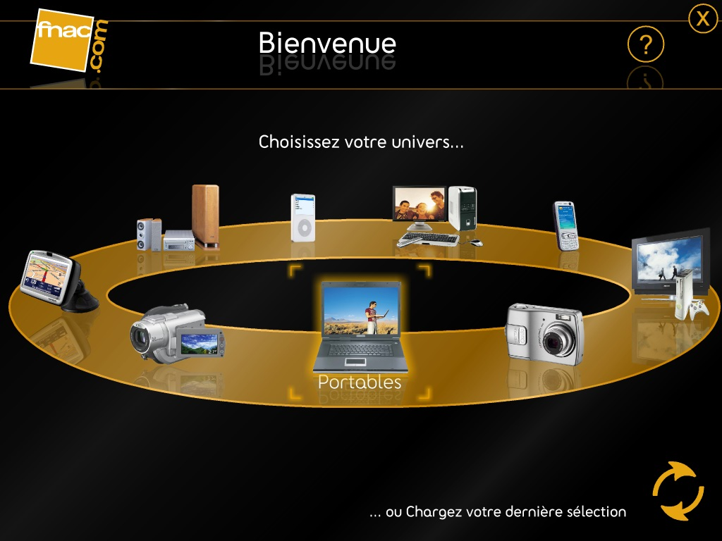
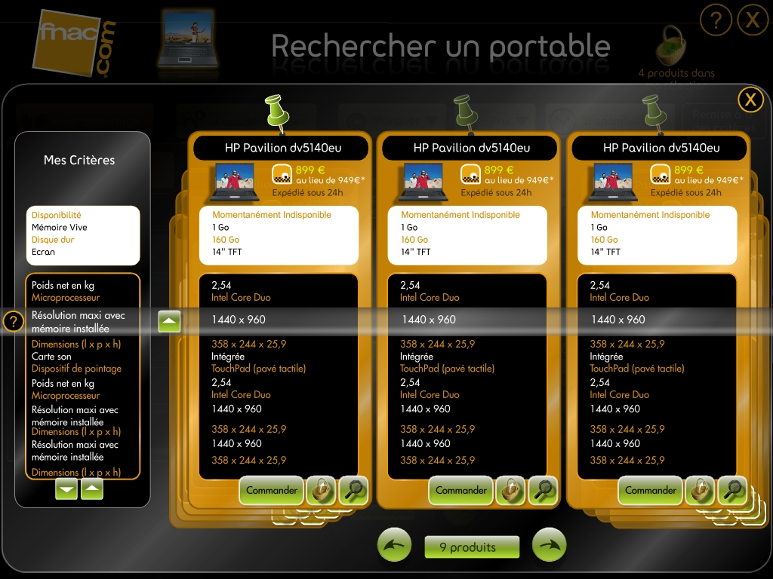
Figure 2. Dynamic product comparisons

To develop a rich user interface, as shown in Figure 1, developers used Microsoft Expression® Interactive Designer—software that helps developers create streamlined, innovative, and visually appealing applications—and Windows Presentation Foundation (formerly code-named “Avalon”). Windows Presentation Foundation technology provides multi-language support, making it simple to manage localization for a selection of countries and languages, and also supports 3-D product presentations. Leprou explains, “Using .NET–connected technology, customers can view a product by rotating a 3-D image. This capability helps simulate an in-store buying experience even when the customer is online.”

Benefits
With the smart application, FNAC looks forward to mirroring, on its Web site, the same, high-quality, informative help a customer receives in a store. Not only does FNAC expect to simplify the product selection process and deliver a consistent buying experience (both in stores and online), but the company also expects to see an increase in product sales through its Web site.

Leprou explains, “With our new Web site and kiosks, we’re providing a better purchasing experience for our customers, both online and in stores. Using the .NET Framework 3.0, we’ve improved the product search and comparison functionality, and simplified the entire purchasing process.”
“We’ve added a personal touch to our Web site with detailed product comparisons and 3-D product views. Our customers will be motivated to purchase products—thereby increasing our online sales.”
Frank Leprou, General Manager, FNAC.com

Better Product-Selection Process
With the smart client application, it’s easier for customers to access product information, compare products against one another (see Figure 2), and to view products more completely (now that they appear as dynamic 3-D graphics). In addition, one of the most important highlights of the new smart application is that customers have multiple ways to search for products. Now, customers can search based on their usage or technical needs. For example, a customer looking for a laptop can specify the primary use of the product--such as multimedia--and instantly access a list of products that meet those specific use requirements. Or, a customer can identify specific technical needs and browse only the items that match up.

“The features that we’ve added to the application all contribute to an improved experience for our online customers,” says Leprou. “In addition, using .NET technology, we’ll be able to constantly evolve the application to ensure it continuously meets the growing needs of our customers.”

Consistent Online and In-store Buying Experience
The improved customer experience doesn’t stop online. Because FNAC is implementing the same application on touch screen, in-store kiosks, customers can get all the information they need to make a purchasing decision, even when a salesperson is not available.

“It’s important that we support a certain level of consistency for customers, and we’ll achieve this goal by completing a dual-implementation of the application,” says Leprou. “No matter where a customer is—at home or in one of our stores—and, regardless of whether a salesperson is available to help, that customer will be able to use the kiosks to find a deep level of product information.”
Increased Online Sales
While FNAC.com already experiences a high-level of business through its Web site, the company expects that the new application will open the door to a new client segment.

“We know there is a certain segment of our Web site visitors who use our Web site purely for product research and do not buy. In the end, this segment misses the help an in-store sales person can offer,” says Leprou. “We’ve added a personal touch to our Web site with detailed product comparisons and 3-D product views. Our customers will be motivated to purchase products—thereby increasing our online sales.”
Windows Vista
For More Information
For more information about Microsoft products and services, call the Microsoft Sales Information Center at (800) 426-9400. In Canada, call the Microsoft Canada Information Centre at (877) 568-2495. Customers who are deaf or hard-of-hearing can reach Microsoft text telephone (TTY/TDD) services at (800) 892-5234 in the United States or (905) 568-9641 in Canada. Outside the 50 United States and Canada, please contact your local Microsoft subsidiary. To access information using the World Wide Web, go to: www.microsoft.com

For more information about FNAC products and services, call 33 01 55 21 57 93 or visit the Web site at:
www.fnac.com

Software and Services  - Windows Vista  - Microsoft Expression Interactive Designer  - Microsoft Servers  - Microsoft SQL Server 2005 Enterprise Edition  - Microsoft Visual Studio  - Microsoft Visual C# | - Technologies  - Microsoft .NET Framework 3.0  - Windows Communication Foundation  - Windows Presentation Foundation

Windows Vista can help your organization use information technology to gain a competitive advantage in today’s new world of work. Your people will be able to find and use information more effectively. You will be able to support your mobile work force with better access to shared data and collaboration tools. And your IT staff will have better tools and technologies to enhance corporate IT security, data protection, and more efficient deployment and management.

For more information about Windows Vista, go to:
www.microsoft.com/windowsvista

© 2006 Microsoft Corporation. This case study is for informational purposes only. MICROSOFT MAKES NO WARRANTIES, EXPRESS OR IMPLIED, IN THIS SUMMARY.

Document published November 2006

